**Fixed Income PS 1 - Case 2**

Group 9 - Yuhua Deng, Xiahao Wang, Nupur Solanki, Haoxuan Tong

In this case we evaluated the long/short strategy of the principle stripe bond and coupon stripe bond for one-year period starting Jan 2nd, 2014. The principle stripe bond and coupon stripe bond with the same face value should have identical price, but in reality, there exists a small spread. Thus, there is an arbitrage opportunity that we can exploit.

Table 1 shows the construction of the portfolio, and its profit by mark to the market everyday. If we long 1 unit of the principle stripe bond (lower price) and short 1 unit of the coupon bond (high price), the spread of $0.196 will be realized arbitrary profit if we hold to the maturity. However, the price discrepancy between the strip bonds may widen or shirk over time, resulting in daily profit and loss.

**Table 1**

|  |  |  |  |  |
| --- | --- | --- | --- | --- |
| Date | Long Position | Short Position | Daily Return (%) | Cumutive Return ($) |
| 2014-01-02 | 73.184 | 73.38 | 0 | 0 |
| 2014-01-03 | 73.21309652 | 73.40831451 | 0.000162097 | 0.000810483 |
| 2014-01-06 | 73.24316465 | 73.44061277 | -0.000440332 | -0.001391176 |
| 2014-01-07 | 73.27742909 | 73.47521017 | -6.08966E-05 | -0.001695659 |
| 2014-01-08 | 73.29491561 | 73.52320864 | -0.006096697 | -0.032179144 |
| 2014-01-09 | 73.32007314 | 73.56831403 | -0.003983879 | -0.052098539 |
| 2014-01-10 | 73.35457249 | 73.59931255 | 0.000705863 | -0.048569224 |
| 2014-01-13 | 73.37624963 | 73.62736197 | -0.001268762 | -0.054913032 |
| 2014-01-14 | 73.41399442 | 73.66195789 | 0.000635466 | -0.051735703 |
| 2014-01-15 | 73.44284539 | 73.69267662 | -0.000367857 | -0.053574991 |
| 2014-01-16 | 73.4585642 | 73.72774658 | -0.003864534 | -0.072897661 |
| 2014-01-17 | 73.4925816 | 73.76047129 | 0.000264232 | -0.071576502 |
| 2014-01-21 | 73.51704102 | 73.79338384 | -0.001684933 | -0.080001167 |
| 2014-01-22 | 73.5542264 | 73.82974783 | 0.000169973 | -0.079151304 |
| 2014-01-23 | 73.57264656 | 73.85817614 | -0.001995934 | -0.089130976 |
| 2014-01-24 | 73.59047029 | 73.88233273 | -0.001260877 | -0.095435363 |
| 2014-01-27 | 73.61711907 | 73.9164676 | -0.001491525 | -0.102892985 |
| 2014-01-28 | 73.65358652 | 73.94797401 | 0.000997903 | -0.097903468 |
| 2014-01-29 | 73.68222728 | 73.97581852 | 0.000164943 | -0.097078752 |
| 2014-01-30 | 73.71138901 | 73.99999782 | 0.001002179 | -0.092067856 |
| 2014-01-31 | 73.74000289 | 74.032184 | -0.000708766 | -0.095611685 |
| 2014-02-03 | 73.75436087 | 74.07806699 | -0.006299307 | -0.127108221 |
| 2014-02-04 | 73.78016723 | 74.10328785 | 0.000122794 | -0.126494252 |
| 2014-02-05 | 73.80531918 | 74.1278926 | 0.000115137 | -0.125918567 |
| 2014-02-06 | 73.83448295 | 74.15435157 | 0.000546653 | -0.123185302 |
| 2014-02-07 | 73.86785985 | 74.1821324 | 0.001124909 | -0.117560755 |

To have a better understating of the daily P/L, we graphed the strategy portfolio daily return (Graph1) and calculate the statistical summary (table 2). The daily profit/Loss position exhibits a approximately normal distribution, as short term price movements follow a Brownian Motion process.

**Graph1**

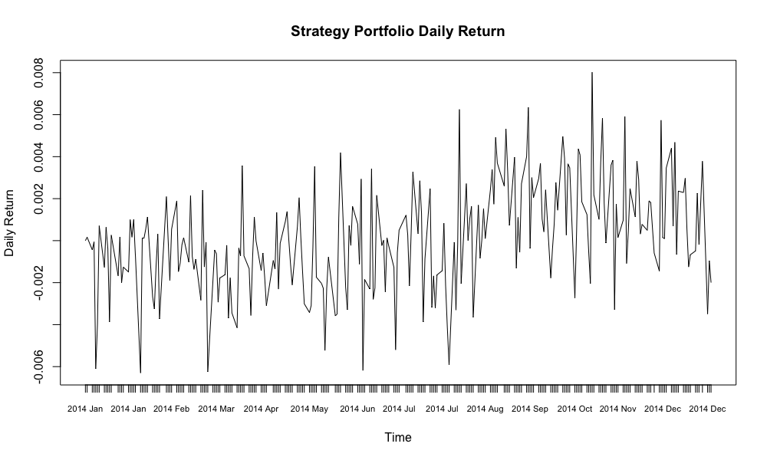

At the same time, we can observe slightly negative skewness and thicker tail. The 1% quantile is -3.15%. That been said, the tail risk is high. Before realizing the profit, there are chances that the portfolio became extremely highly levered.

**Graph2**

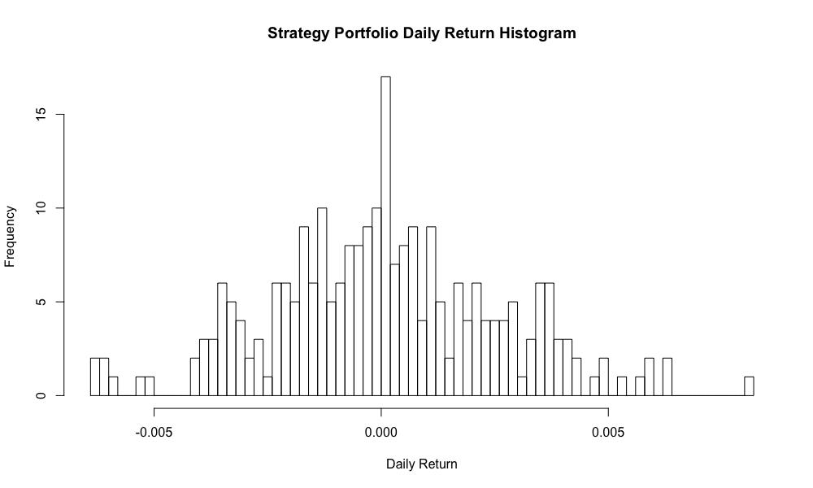

**Table 2:**

|  |  |  |  |  |
| --- | --- | --- | --- | --- |
| Mean | SD | Skewness | Kurtosis | Sharp Ratio |
| 0.02369402 | 0.04019753 | 0.1246374 | 0.07286435 | 0.5894397 |

**Graph 4**

The last Graph illustrates the daily position with accumulated return, confirming our conclusion that the arbitrage profit will eventually be realize, but during the process the portfolio may appear to be highly risky due to price movements.